AWS Cloud First Challenge
1. Launched EC2 instance using Amazon Linux 2.

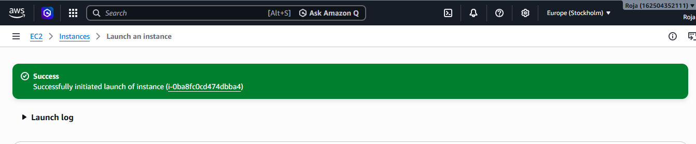
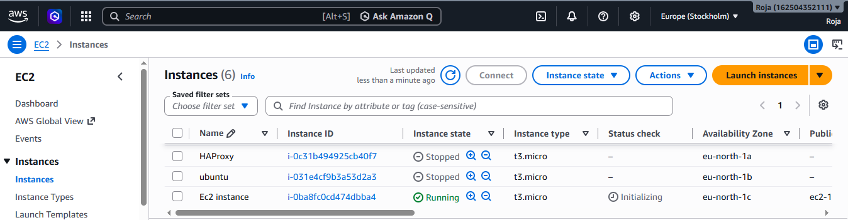

2. Install Docker
sudo yum update –y

To know the operating system used cat /etc/os-release and see it is Amazon linux 2023.
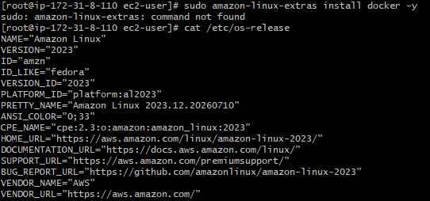

sudo dnf install docker –y
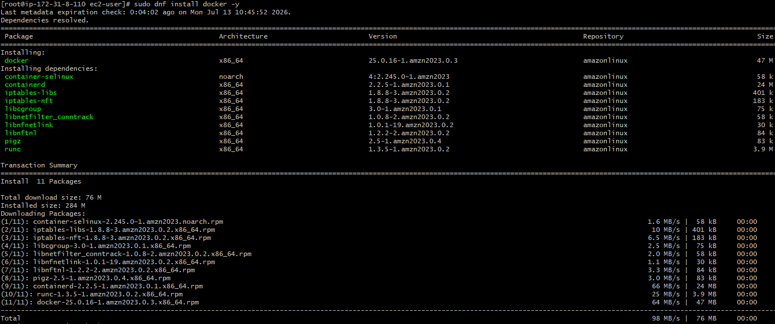
Installed Docker
Then enabled Docker using syatemctl enable docker.
To start docker used systemctl start docker
Verified docker version using docker --version
3. Install Jenkins:
Update server using sudo dnf update –y
Checked java version using Java --version
Installed Jenkins using sudo dnf install jenkins -y
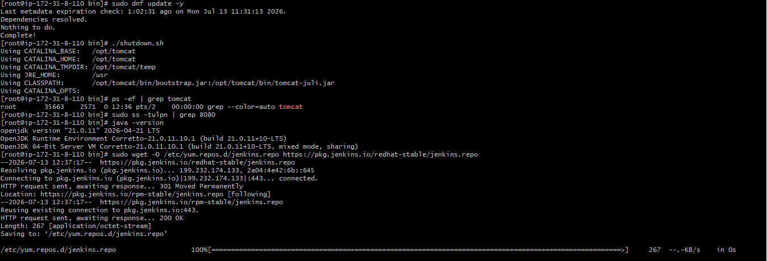

Added Jenkins repository and imported key
Then started, Enabled and checked Jenkins status.
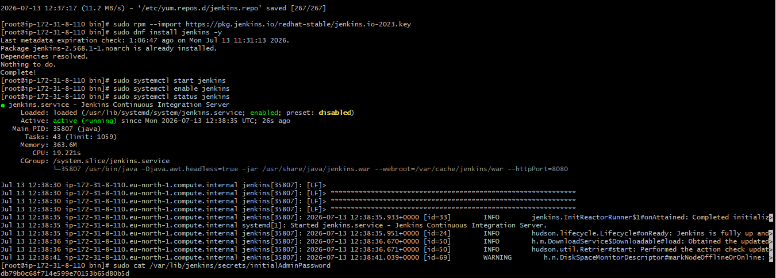

Added inbound rule for Jenkins on port 8080 and verified webpage using http://<EC2-Public-IP>:8080
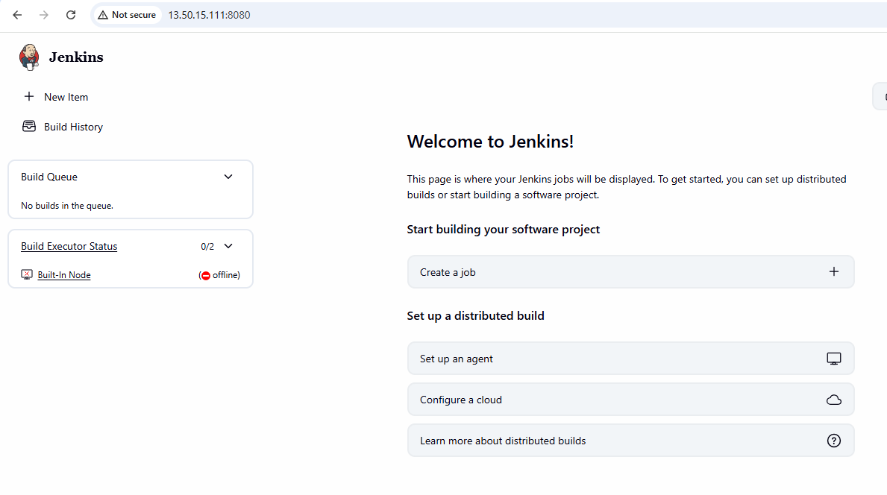

4. Install Apache:
Update syatem using sudo dnf update –y
Install apache using sudo dnf install httpd -y

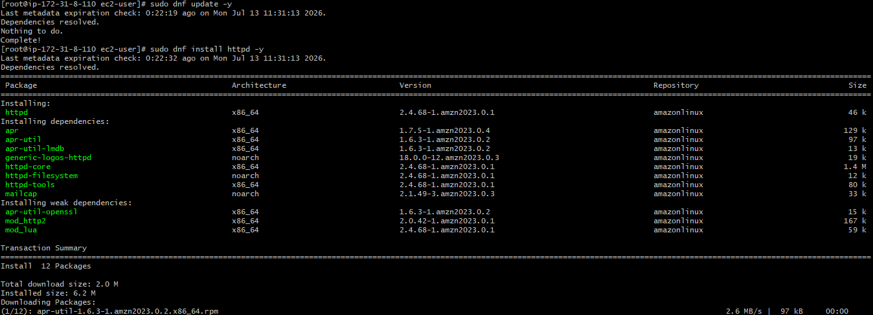
Started, enabled and checked the status of Nginx to see active status
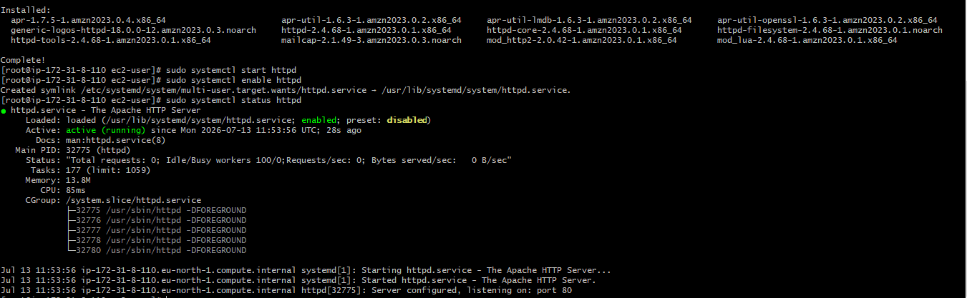
Verified on webpage:
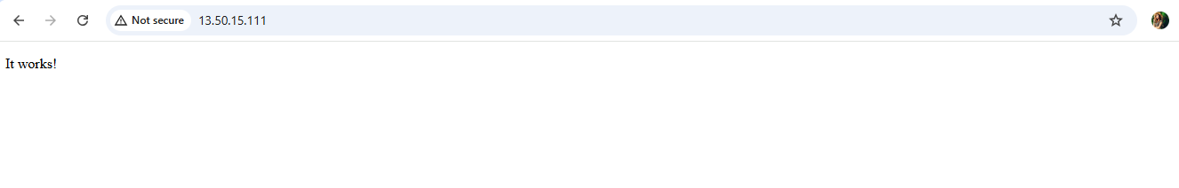

5. Install Nginx.

Update syatem using sudo dnf update –y
Install nginx using sudo dnf install nginx -y
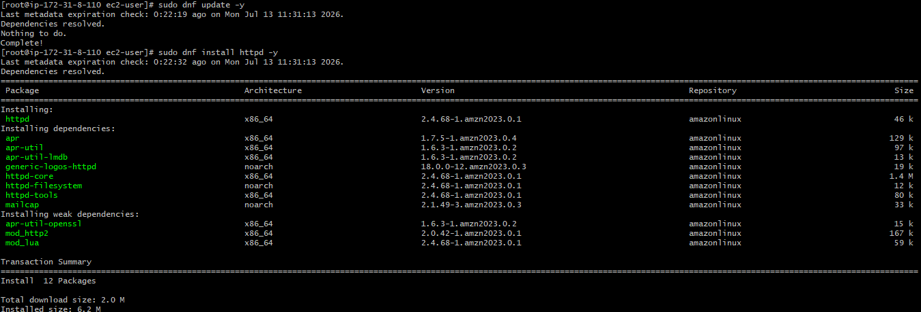

Then started, enabled and checked the status of Nginx to see active status

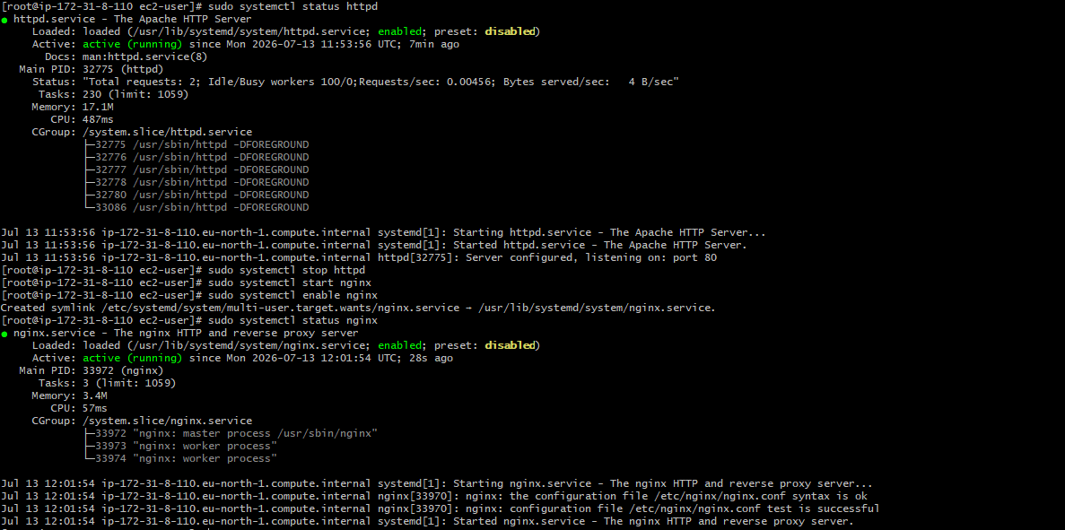

Added inbound rule for custom tcp on port 80 and verified same on the webpage using http://<EC2-Public-IP>
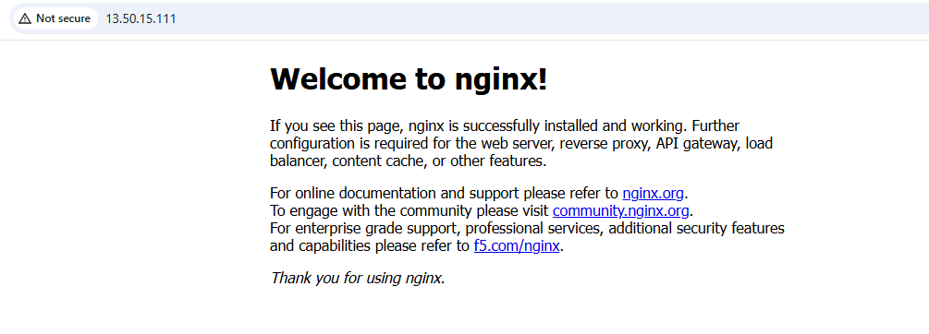

6. Install Apache Tomcat:
